LAUNCH INSTANCE

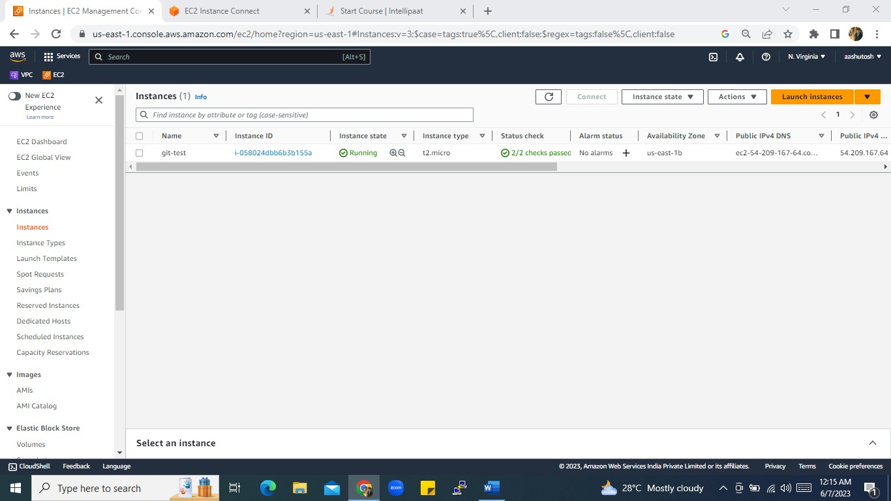

CONNECT INSTANCE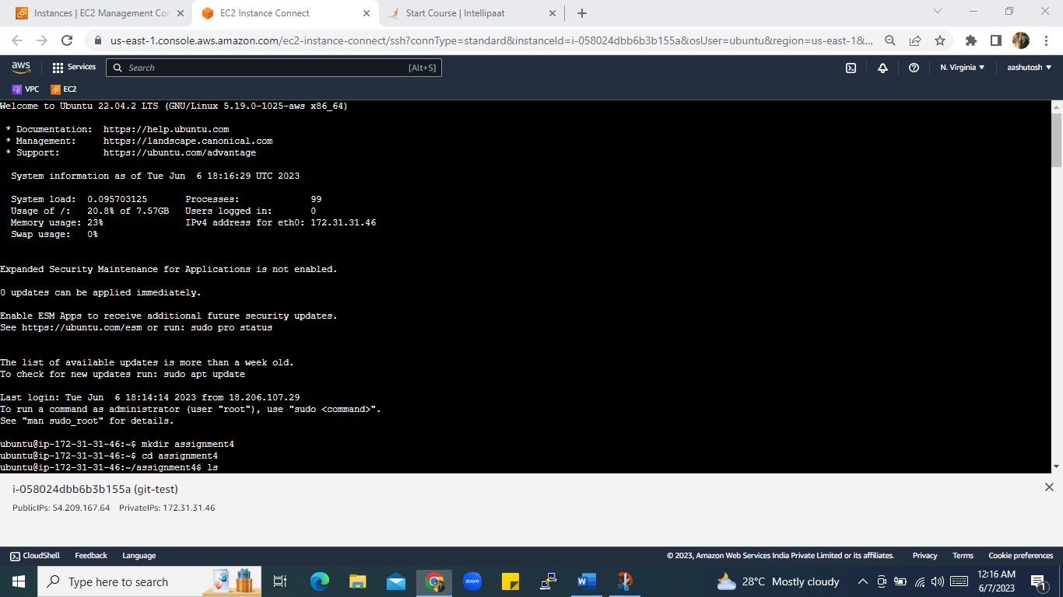

SCREEN SHOT 1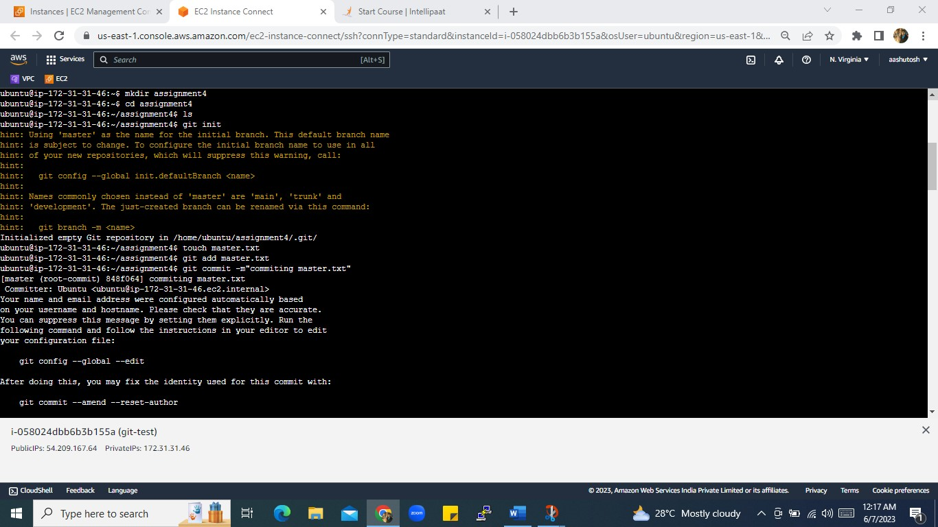

SCREEN SHOT 2

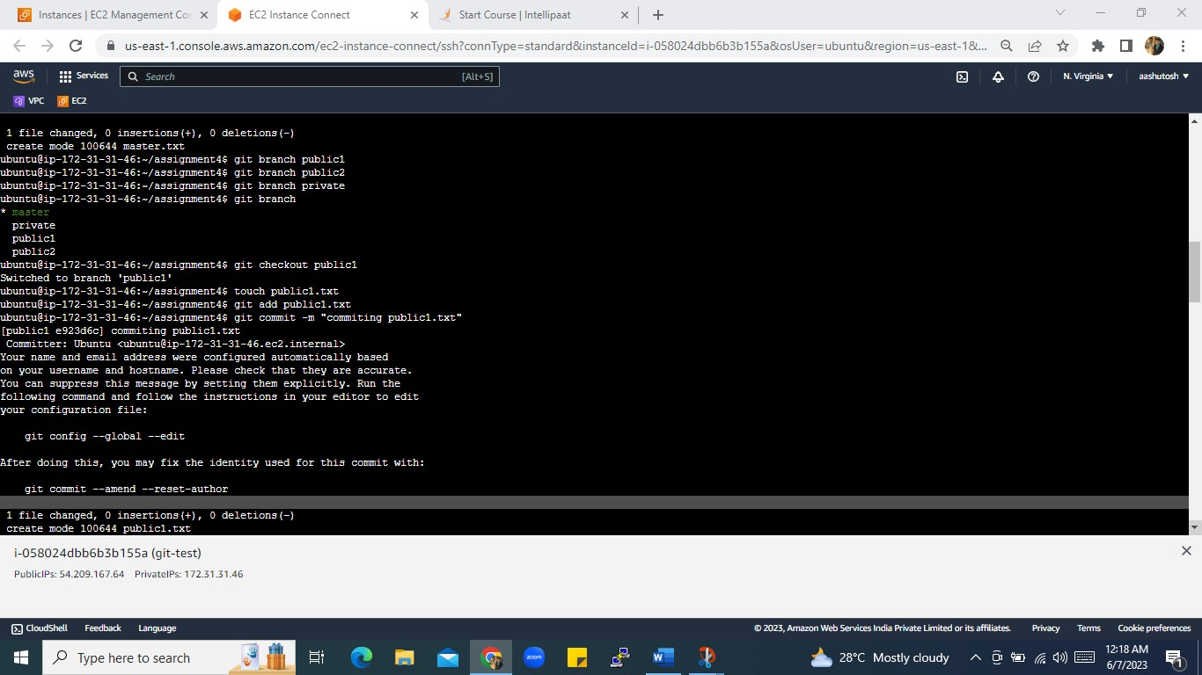

MODIFIED MASTER BRANCH

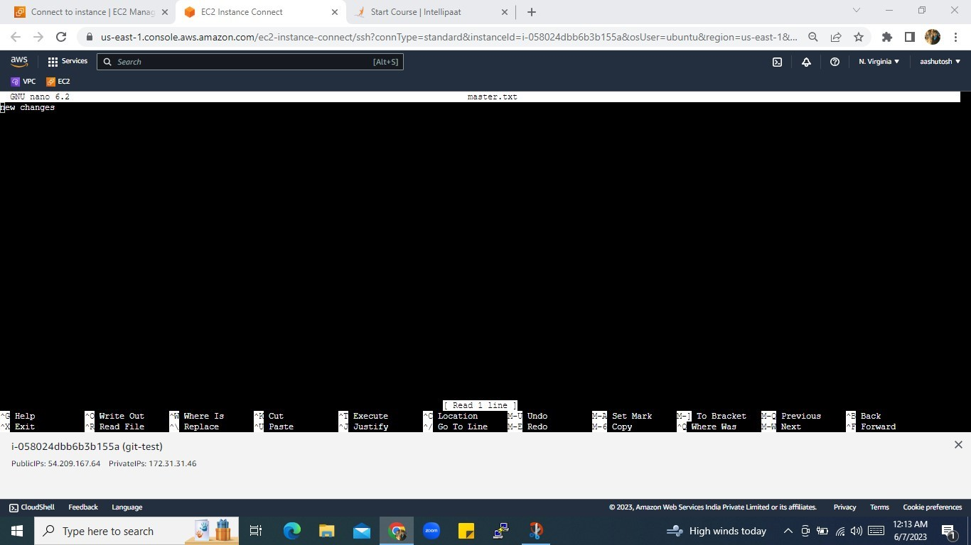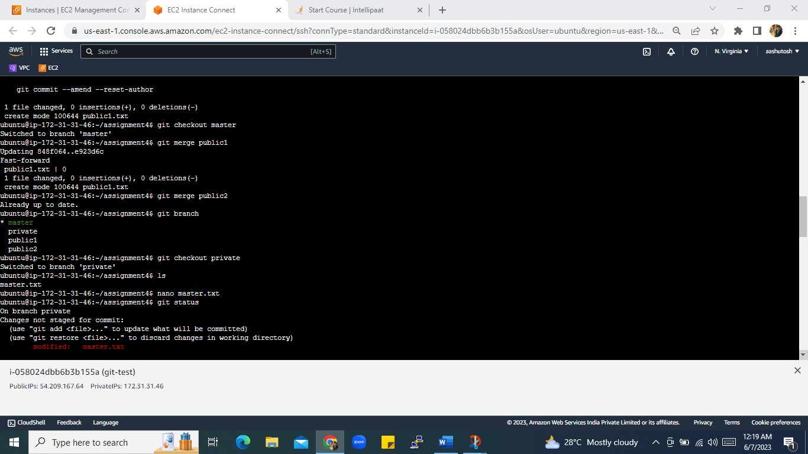

SCREEN SHOT 3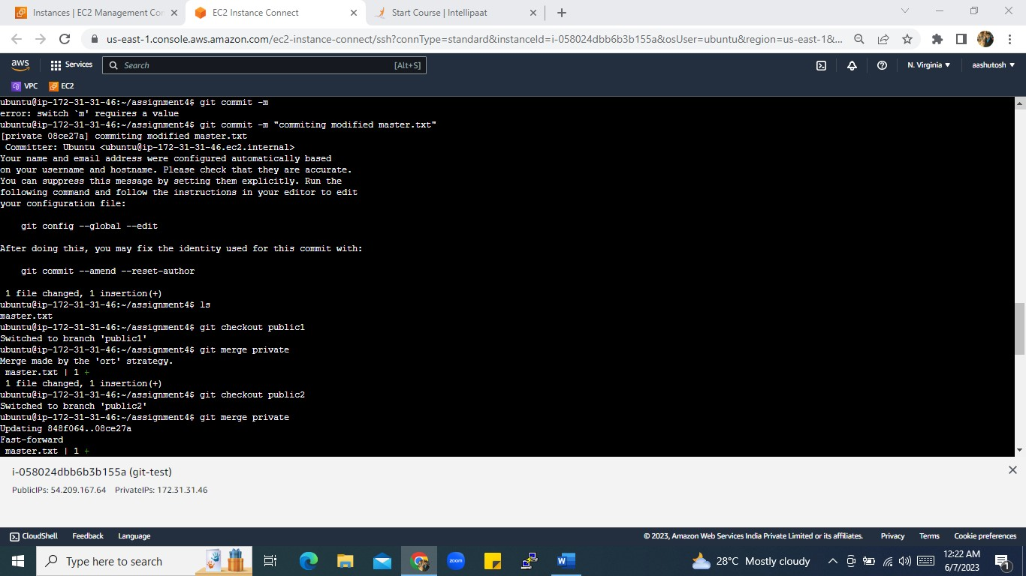

MERGE PUBLIC1 & PUBLIC 2 IN PRIVATE

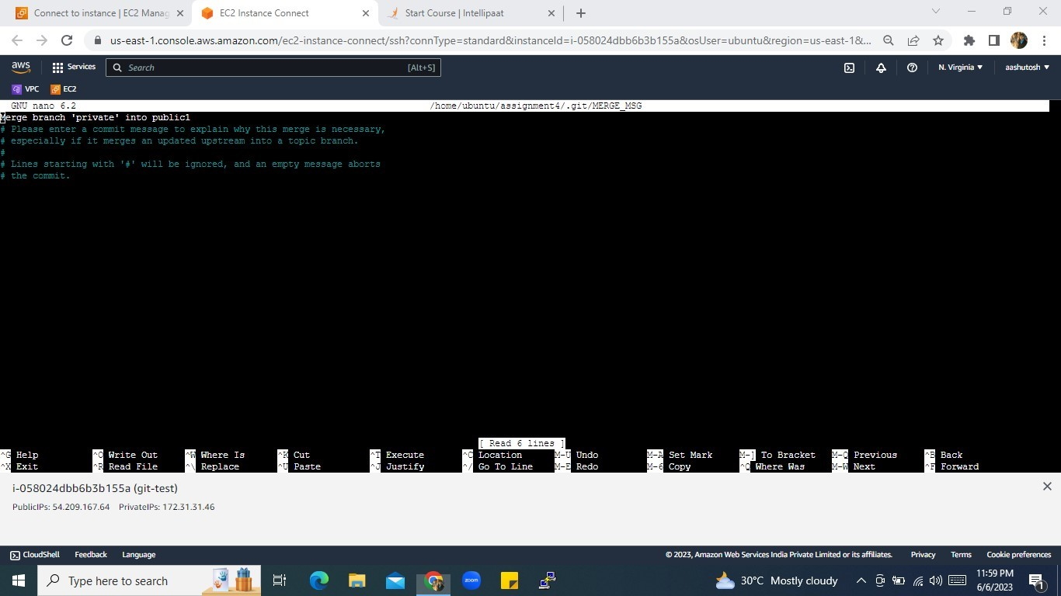

UPDATE NEW MASTER CODE ON MASTER

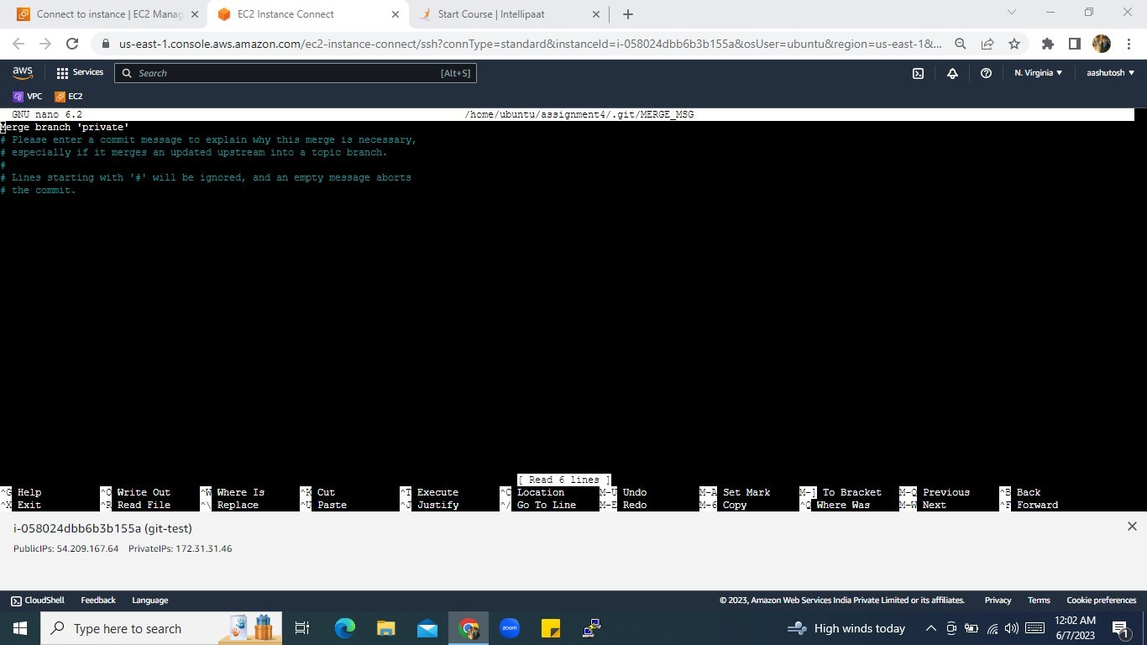

COMMAND HISTORY WHICH ARE USING IN ASSIGNMENT 4

